# **Fitness - Database Design**

Table Structures with relationships among them are given below.

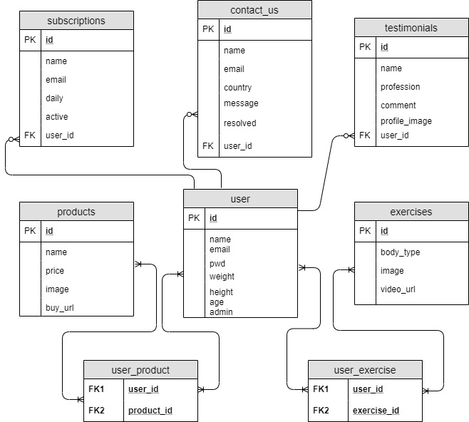

Explanations for the above tables are given below:

**subscriptions**

People may subscribe to the newsletter by filling up a form on a web page. A person may opt for daily newsletter. A person may opt for un-subscription later. A person may or may not be a registered user who subscribe to the newsletter.

**contact_us**

People may contact us for different reasons such as regarding the fitness products, feedback, issues etc. We also mark it as resolved or not. A person who contact may or may not be a registered user.

**testimonials**

People may write testimonials about our fitness products, exercises or calculations on weight loss, maintain weight etc. A person who writes testimonial may or may not be a registered user.

**products**

the table contains different fitness related products which a person may opt to buy and he/she will be redirected to external website for buying the product(s). A person may or may not be a registered user who buys a product.

**exercises**

People would like to know what kind of exercises he/she can do by playing the video. A person may register to opt in for different exercises.

**Users**

This table is used to store user information once a user registered through portal. We also differentiate between normal and admin users.

We have two more tables with many to many relationships – **user_product** and **user_exercise**. Many users may buy the same products or vice versa. Many users can do the same exercise.

**Database Server** – MySQL

**Type** – RDBMS

**Advantages:**

MySQL is free open source database that facilitates the effective management of the databases by connecting them to the software. It is a stable, reliable and the powerful solution with the advanced features.

1. Data Security

2. On-Demand Scalability

3. High Performance

4. Round-the-clock Uptime

5. Comprehensive Transactional Support

6. Complete Workflow Control

7. Reduced Total Cost of Ownership

8. The Flexibility of Open Source

**Why Document Database was not chosen?**

The fitness application has some products but this application does not store them into database and when a person purchases a product he or she will be redirected to the external website such as Amazon.

Generally document based database is required when attributes of a particular product may vary and need to be added or removed depending upon some criteria such as seasonal sale, discount etc. But in my application there is no such thing and every object has finite number of attributes. Therefore RDBMS is a good choice.